**Unary Operator Overloading**

#include <iostream>

using namespace std;

class Complex

{

public:

int real, imag;

Complex(int r, int i)

{

this->real = r;

this->imag = i;

}

void operator-()

{

real--;

imag--;

cout << "\nComplex number (Decrement): " << real << "+" << imag << "i";

}

};

int main()

{

Complex c1(8, 9);

Complex c2(6,3);

-c1;

-c2;

return 0;

}

**Output**

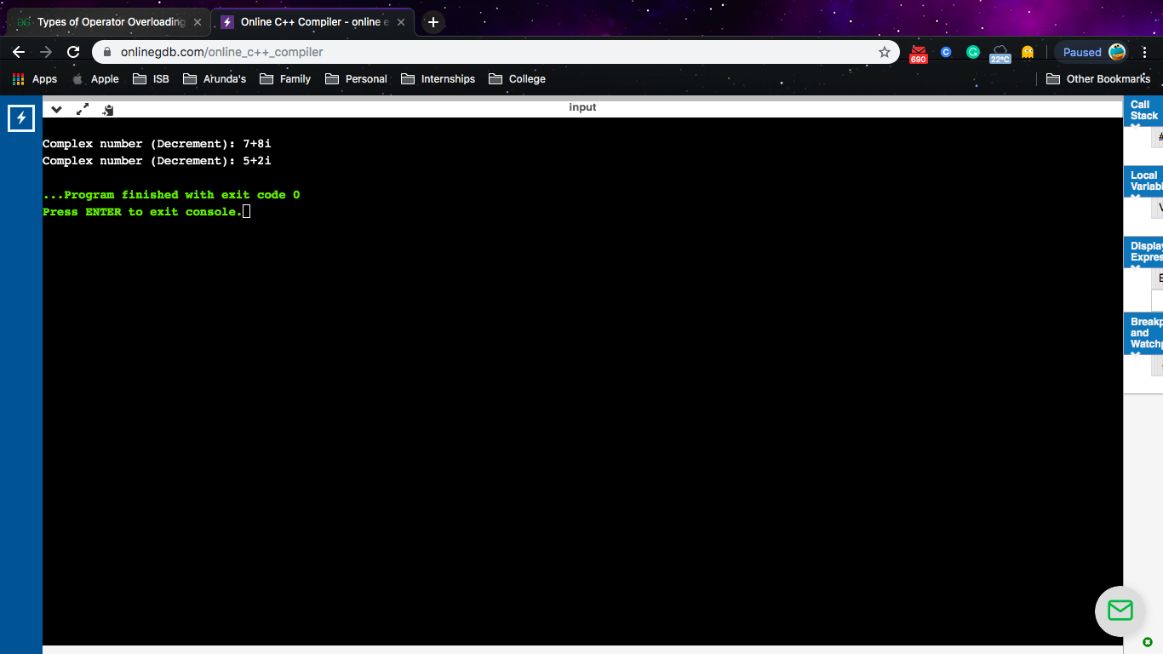

**Binary Operator Overloading**

#include<iostream>

using namespace std;

class Weight

{

public:

int kilograms,grams;

Weight()

{

this->kilograms=0;

this->grams=0;

}

Weight(int kg,int g)

{

this->kilograms=kg;

this->grams=g;

}

void printData()

{

cout<<"Kg:"<<kilograms<<"g:"<<grams<<endl;

}

Weight operator+(Weight &w2)

{

Weight w3;

w3.kilograms=this->kilograms+w2.kilograms;

w3.grams=this->grams+w2.grams;

return w3;

}

};

int main()

{

Weight w1(8,15);

Weight w2(19,67);

Weight w3;

w3=w1+w2;

cout<<"Total weight:"<<w3.kilograms<<"."<<w3.grams;

}

**Output**

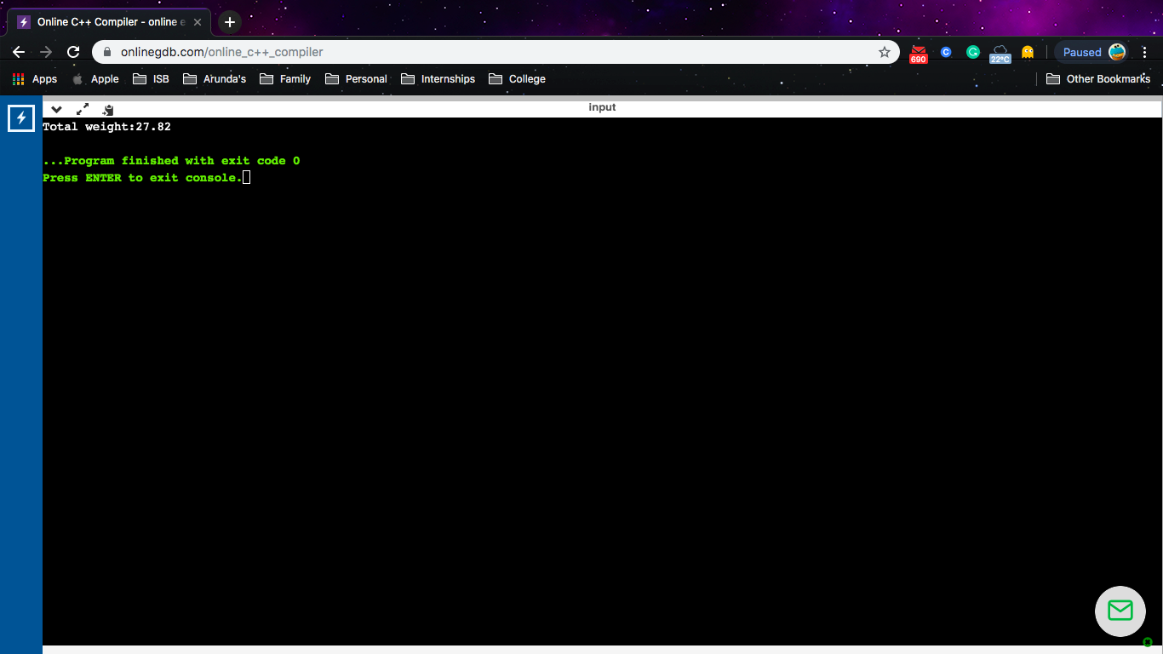

**Friend Function Overriding**

#include <iostream>

using namespace std;

class Number

{

private:

int a;

public:

void getNum(int x);

friend void printNum(Number no);

};

void Number::getNum(int x)

{

a=x;

}

void printNum(Number no)

{

cout << "Value of number: " << no.a;

}

int main()

{

Number nObj,nObj1;

nObj.getNum(1000);

printNum(nObj);

cout<<"\n";

nObj1.getNum(500);

printNum(nObj1);

return 0;

}

**Output**

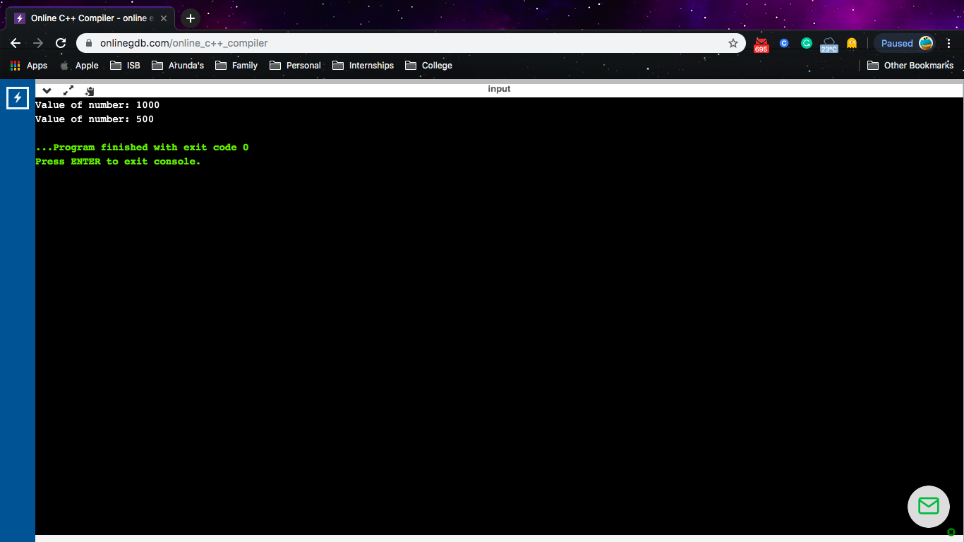

**Member Function Overriding**

#include<iostream>

using namespace std;

class Number

{

public:

void show()

{

cout<<"Number";

}

};

class Prime: public Number

{

public:

void show()

{

cout<<"Number is prime";

}

};

int main(void)

{

Prime p = Prime();

p.show();

return 0;

}

**Output**

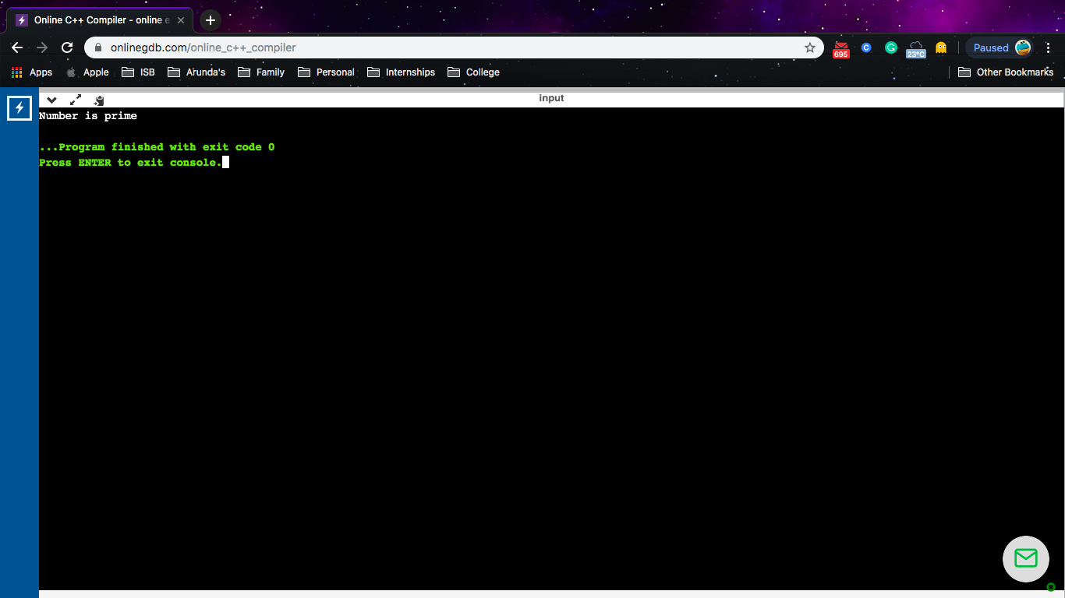

**Member Function Overloading**

#include<iostream>

using namespace std;

int sub(int x,int y)

{

cout<<x-y;

}

int sub(int x,int y,int z)

{

cout<<x+y+z;

}

int main()

{

sub(8,5);

cout<<"\n";

sub(10,15,70);

}

**Output**

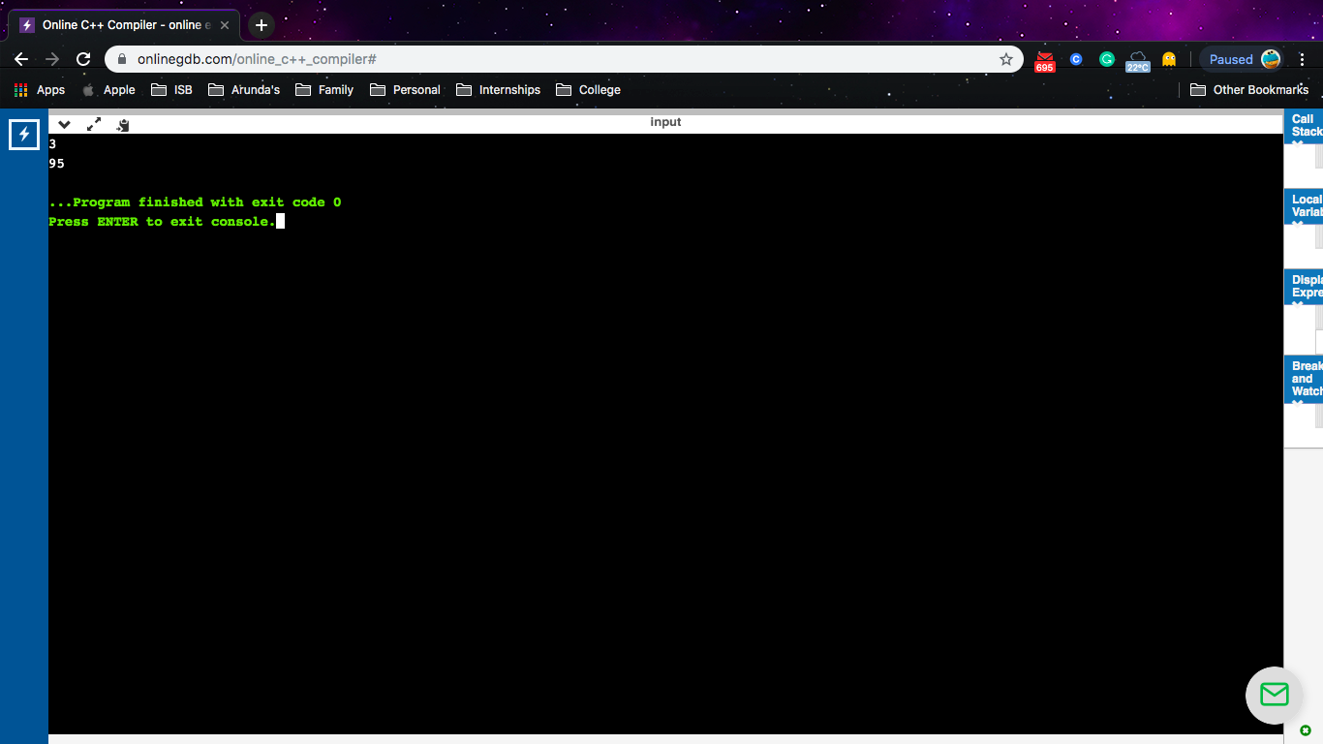

**Friend function overriding**

#include<iostream>

using namespace std;

class complex

{

float real,imag;

public:

complex()

{

real=imag=0;

}

complex(float r,float i)

{

real = r;

imag =i;

}

friend complex operator - (complex c)

{

c.real=-c.real;

c.imag=-c.imag;

return c;

}

void display()

{

cout<<"\nReal:"<<real;

cout<<"\nImag:"<<imag;

}

};

int main()

{

complex c1(1,2),c2;

c1.display;

c2=-c1;

cout<<"\nAfter negation\n";

c2.display();

}